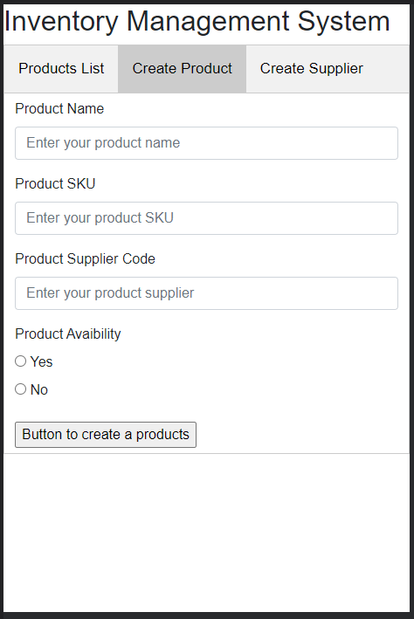

Responses

Requests

Dot Net Restful API

Microsoft sql server

User Interface

Option 1: Product list

Option 2: Create Product

Option 3: Create Supplier

Database

Eg:

ProductDetail

ProductSupplier

Api Gateway

Get Method: GetProducts

Post Method: CreateProduct, CreateProductSupplier

Database Query

HTML



